ABA Therapy for Thumb Sucking
Student’s Name:
University’s Affiliation:

ABA Therapy for Thumb Sucking
Abstract
This paper is an analysis for the ABAB (Reversed design) treatment of finger sucking of two-five years old girls. The research takes two parts: phase 1 functional analysis results revealed that the habit of the two girls had the highest occurrence during fingers- free condition (alone condition). Therefore, an automatic reinforcement maintained the behavior. The phase to analysis pointed out that engaging the hands of both girls reduced thumb- sucking. The treatment involved the holding of a ball for each child in alone condition. The treatment reduced the occurrence of finger sucking to zero for one participant, whereas the other should moderate reduction. However, the particular participant responded well with positive punishment.
Introduction
Research holds that thumb sucking is familiar with children aged 1 to 4, and the occurrence ranges from 23% to 46% (Tanaka et al., 2016). The common habits among human beings include thumb sucking, foot tapping, and nail biting, hair pulling and eye blinking. The habits develop during childhood and if parents ignore or does not find the stimulating agent for the behaviour, the habit may persist even in the late developmental stages of the children. Usually, the habits appear normal and therefore, they do not demand a lot of attention from parents and medical practitioners. However, it is advisable for the adults to curb such behaviours before the children enter transit to the adolescent stage with them. Once a child realises that he or she has a weakness, he or she lives life full of embarrassment and self- hate. When parents or teachers realise the dangers of any habit with their children, they may refer them to medical or counselling professionals. The latter intervene with children thumb sucking habit using ABA behaviour modification models. Thumb sucking as a common habit manifesting in the early stages of children need to be addressed.
The behaviour looks normal but it has adverse effects to the lives of the victims if parents, teachers, medical professionals and the general public do not institute early intervention programs for the affected children. Research show that thumb sucking affects between 30- 40 percent of children below the school age (Tanaka et al., 2016). Also, statistics point out that 10- 20 percent of the school age children (6 years old) suck their thumbs and only 5% children thumb suck at age 11. Research further holds that thumb sucking to children below age 6 not typically problematic but if it exceeds that age, it becomes chronic and may alter the developmental process of the children. For instance, thumb sucking is known for its effects on dental formula and speech function. It can also lead to communication adversities between the victims and their parents or among peers (Tanaka et al., 2016). People seem to assume thumb sucking habit until it becomes chronic and appears to bring adverse problems to the child. Therefore, the behavior needs to be curbed before it extends age 4 and affects the developmental health of a child. This paper will explore the thumb sucking behavior of two girls aged 5. The research aims to give a clear understanding of how alternating measurement would be conducted in an ABAB with intervention withdrawal (reversed).
Literature Review
According to research by Woods and Miltenberger (2006), there are typically two types of thumb sucking: nutritive and non- nutritive sucking. The nutritive sucking involves bottle- feedings and breastfeeding while the non- nutritive sucking involves sucking on objects that are not nutritive. Finger- sucking is the standard non- nutritive sucking. Woods and Miltenberger (2006), hold that finger sucking can be chronic if it occurs in two or more places e.g., home and school.
Bishara and Larsson (2007) point out that thumb sucking need to be addressed during the oral phase rest it extends to the next developmental stage. Meeting the sucking needs of an infant refers to fixing of the problem. Also, the scholars hold that thumb sucking habit extends to late developmental stages due to lack of social support and treatment.
Research by Asadollahpour et al. (2015) show reflects that digital sucking is the root cause of tooth mal-position and displacement of the alveolar bone. The latter brings about adverse effects on speech and aesthetics. The results may not bother children because they are always indifferent. However, if the impact advances to their later growth, they become a personal concern.
Research questions
The researched answers three questions:
- Does one type of intervention treat a finger sucking habit of two or more children?
- How does a response with social reinforcement affect finger sucking occurrences?
- How can an alternate measurement be conducted in an ABA design?
Method
Participants
- ABA therapy for thumb sucking involves three groups of participants:
- Two five years old girls (Jane and Mary)
- Two mothers (parents to Jane and Mary)
- Researchers
Research Setting
The development of Jane and Mary was healthily, about to join the first grade. According to Jane's mother, the habit of thumb sucking developed since birth. However, Jane tried all kinds of destructors to stop the practice, but due to the commitment and lack of consistency in her efforts, the habit persisted. Some of the strategies the mother used to eliminate her daughter's thumb sucking included the application of aversive substances as the use of balls and taping Jane's fingers (Tanaka et al., 2016). The mother noted that Jane could suck her fingers while alone and also in the presence of family members. She could thumb- suck while listening to bedtime stories, watching television alone, and while she was in bed. She sucked the third and the fourth fingers of the right hand but occasionally, she could suck from either hand.
Mary, on the other hands, could turn six years in three months time. Her mother reported that the thumb- a sucking habit developed since her infanthood (Yadav 2017). The finger- sucking was intense and occurred while she was alone in bed, and when watching the television. Like Jane's mother, Mary's mother tried to wear her gloves as destructors, but she still continued thumb sucking. Sometimes she could bandage her daughter's fingers, but the intervention was unsuccessful due to the problem of long- term follow up (Tanaka et al., 2016). Mary could suck her third and fourth fingers of the right hand. Another socking behavior was that Mary could strike her face with the fingers of the other hand, not sucked.
Research Procedures
Thumb sucking was the target behavior to eliminate both Jane and Mary. The intervention took place in two phases: the first phase involves observing finger sucking behavior for the two participants while they spent time with their mothers and phase two involved observing the behavior the occurrence of thumb- sucking for each participant while in her living room. Both phases required the use of videotapes to calculate the percentage of each individual participant's behavior. Data collection occurred in 10 and 20 mini- segments through videotaping. However, scores for each segment depended on a real-time videotape recording. The observers agreed to divide each segment into 600 seconds on the scoring sheet (Yadav 2017). Therefore, the occurrence and nonoccurrence of thumb sucking were recorded on the second basis and each segment independently. The observers divided the number of seconds spends thumb- sucking with 600 seconds (the number of seconds for each segment). The second step involved the calculation of the mean percentage for the occurrence or non- occurrence of thumb sucking for each participant (y/600 x 100).
The mean score for Jane's thumb sucking was 89.1 %, and that of Mary was 94. 8 %. Then, the evaluation of finger sucking was based under two conditions: finger free (lone condition) and attenuation condition. The researchers instructed both mothers to withdraw their attention during the baseline period and to engage during the intervention period. The intervention process involved the mothers giving each individual child a ball to hold in order to engage both hands. The ball acted as a destructor. Therefore, the functional analyses for the two children involved alternating free hand with sensory attenuation (Tanaka et al., 2016). During the freehand session, each mother could let her child watch television alone and instruct her not to interfere with what the mother was doing. On the other hand, sensory attenuation session involved social engagement of the child in a play- like activity. Each mother could act friendly to the child by giving her a ball to play with and the show social support. On a different functional analysis instance, the children could be given a ball to hold during bedtime session. The conditions in which the researchers placed the children had the following importance:
- Attention condition: it facilitated the assessment of whether positive social reinforcement maintained the finger sucking habit. The mother could neglect the child but keep observing if she could suck her fingers (Yadav 2017). If the sucking happened, the mother could disapprove the child's habit for approximately five seconds, and then resume her duties.
- Fingers free condition: it was designed to assess how often the baby could finger- suck in the absence of social support.
- Control condition: this condition facilitated physical attention and involved each mother playing with her child using a ball. The ball could make each child engaged and therefore destruct the habit. Also, the researchers instructed the mothers not to disapprove the children if they sucked the fingers during the control condition.
Results
Phase 1
Phase 1 testing of the participants' reactions under different conditions occurred over a one month period. The results for the occurrence of thumb sucking were recorded under each condition. The results for each participant were as follows:
Jane: Finger sucking recorded high during the finger free condition. The child was alone, and therefore, she comforted herself through finger- sucking. The percentage for thumb sucking was 73. 5%. The percentage went up when the lone condition (fingers- free condition) was repeated for the second and third time (95. 4%). However, the children portrayed a substantially lower level of finder sucking with the attention condition (50. 7). Jane's mother exposed her to the attention condition for three sessions, and by the third session, the percentage for Jane's finger sucking habit recorded zero. Under this condition, the mother seemed to punish Jane's finger sucking. However, finger sucking did not occur with the control condition. This indicated that positive social reinforcement made the girl stay engaged, and therefore, she could not find time to finger suck. The occurrence of finger sucking during Jane's nap was zero. She slept holding a ball which could not allow her to finger- suck.
Mary: the finger sucking habit seemed to be high during the lone condition (fingers- free). It went up to 51. 8%. However, the attention condition seemed effective for curbing Mary's finger sucking habit because it reduced to 50.6% and the dropped to zero during the second exposure. The results suggest that social disapproval of the finger sucking habit acted as the destructor. There was no occurrence of finger sucking with the control condition, but when her mother gave her a ball to hold in her bed, she dropped it and preferred sucking her fingers. The percentage for finger- sucking in her nap was 47 — 4 %. However, the repetition of this condition resulted in substantially lower level 39. 5%.
Phase one results did not give a clear suggestion for the correct intervention method. For Jane, the introduction of a ball seemed to curb the finger- sucking habit (Tanaka et al., 2016). She recorded positive results with the introduction of the ball during the control condition session. However, she also responded positively to her mother's disapproval of her finger- sucking. With the napping condition, while holding a ball, the results give a dim suggestion that Jane could stop her finger- sucking habits if her hands stay engaged.

On the other hand, Mary portrays reduced level of thumb- sucking when exposed to attention condition. Also, she does not record any finger- sucking occurrence with the control attention. This suggests that she responds positively with both negative and positive social reinforcement. However, when her mother gives her a ball she does not find pleasure in holding it till she falls sick. Instead, she prefers sucking her fingers and therefore, the occurrence of finger- sucking in her nap counts high (Tanaka et al., 2016). For this reason, the researchers opted for a second phase of intervention but this time they used the ABA design of monitoring behavioural changes when reinforcement was introduced and when it was withdrawn. The second phase aimed at getting the correct intervention.

ABAB Reversed Intervention Design
For the second time, finger- sucking history for the girls was recorded. Jane was a five-year-old girl who could search her thumb, especially when her mother and other relatives appeared withdrawn. The occurrence of finger sucking was high during fingers- free times, usually when she was in the living room idly watching television. Her mother affirmed that Jane could also thumb suck when she was bored or stressed. According to her mother, finger sucking habits occurred at its lowest when she was engaged, either in a conversation or holding an object. Jane's dentist had earlier warned that if the habit persists beyond age 6, the girl could develop malocclusion. He warned that the girl was likely to develop malocclusion V, which characteristic of protruding front upper teeth. When the first in intervention program was administered, which involved handing over a ball to her both in the day time and at night, thumb sucking did not occur. However, the researchers decided to use a reversed method to see what could happen to her habit if they applied withdrew and applied intervention at some intervals.
Mary, on the other hand, did not show any reduction of thumb sucking during her nap. However, her thumb sucking when her mother revoked her, it reduced but in a problematic way. Also, she portrayed some level of resistance with positive social intervention, but later, the occurrence of finger sucking dropped to zero. The phase 1 intervention aimed at provoking the finger sucking behavior to see how the children might respond to phase two interventions. The intervention included the reverse design for finger therapy. According to Mary's mother, her daughter developed thumb-sucking at age 2. The thumb sucking was intense, especially some minutes before nap time and very early in the morning. Later, the habit extended to other times of the day. The mother also reported that when someone shouted at the baby, she could stop sucking. She reported that she occasionally gave her child something to hold in order to engage her, but the results were still negative. The same was proven when the researchers introduced her to ball holding alone. However, when the researchers applied attention treatment, the behavior reduced to zero in a period of ten days. The researchers decided to expose her to the same therapy as Jane in the second intervention phase.
Phase Two Intervention (Reverse Model) and Data Collection
The researchers defined the habit as placing fingers or the thumb of either hand slightly past the plane of the lips then closing the slips. The children could then apply some force to the upper teeth as they enjoyed the sucking sensation (Ellingson et al., 2000). The observers collected data using videotapes and regular observation and recording by both mothers. The observation and recording could not happen all the time since each of the girls sucked her thumb or fingers and removed the thumb or fingers from her mouth. Once the fingers or the thumb were wet, the participants wiped them on their clothes or pajamas. The two mothers were instructed to record data in the morning and before the children could go to sleep. The observation period lasted for 30 minutes during the two times. Nothing was changed in the girls evening routine. They watched the television, engaged in stories and plays. The object which was introduced is the ball, and the children were expected to hold them when either seated idly listening to stories or watching a television or during playtime (Ellingson et al., 2000). All the other events occurred as usual. Since the data was collected early in the morning and late in the evening, inter- observers results were assessed within four observation periods, which was 10% of the total observation periods. The percentage of finger- sucking occurrences was analyzed by professional psychologists using computation method. The officer divided the smallest number of recorded occurrences against the highest recorded number for each girl, and they multiplied the results by 100%. Their agreement resulted in an average of 93.7%.
Experimental Design
The intervention method was a reversed model design. Usually, the procedure used for the model was Baseline- treatment- baseline- treatment. In a more concise manner, the model assumed the formula ABAB a treatment- withdrawal design (Ellingson et al., 2000). The treatment B applied to both girls, and the period of exposure to the intervention was the same. The intervention design helped the researchers to evaluate the effects of the ball held on the finger sucking habit of the two girls.
Research procedure in phase 2 intervention
Baseline: data was collected for the occurrence of a finger- sucking for five days. During the baseline period, the mothers were instructed not to interfere with the girl's finger sucking habit. Also, no object was given to them at this period because the observers were interested in recording the behavior of the girls during the finger- free period.
Treatment: both girls were introduced to ball holding a ball each. The first treatment period proceeded for nine days and involved handing and removal of the ball (Ellingson et al., 2000). The mothers were also instructed to remain neutral in their reactions because responding positively or negatively to the finger- sucking habit could have altered the results.
Reversal: the reversal intervention involved the removal and return of the ball for five days. The exercise occurred to both girls, and data were recorded for the changes observed with each.
Treatment: the second time for the treatment involved the handing and removal of the ball and the treatment period lasted for ten days.
Maintenance: the observers assessed the behavior of girls during the second week following the termination of the intervention. Also, they assessed the girl's behavior after an interval of two moths (Ellingson et al., 2000). All the data was collected using the methods described in the intervention section. The researchers exposed the children to alternating conditions to identify the pattern of the target behavior. The ABAB pattern is a reverse one with the pattern: Baseline – intervention- baseline- intervention. It implies that the children’s thumb-sucking habit was observed at fingers- free condition for about ten (Tanaka et al., 2016). The observers recorded data just as they did in phase 1. Then, intervention followed. It involved giving each child a ball to hold. What changed in this phase is that the parent’s social support was withdrawn. The intervention occurred for duration of 20 minutes. The observers used videotape to record the observation. However, all the occurrences of fingers- sucking happened in a real-time recording. The intervention period was followed by the baseline period then intervention. Recording followed the same pattern for about three months.
With the ABAB pattern, Jane’s initial baseline condition resulted in 93.4% occurrence of thumb- sucking. However, the level dropped to 45.7% by the fifth segment of recording and then to zero by the tenth segment. With the intervention, the first data recorded 50. 6 % and then the occurrences reduced to zero by the fifth segment. For Mary, the initial baseline segment (fingers- free recording) results read high (96.2%). Then, the occurrence substantially reduced to 67% and rose to 88.7% by the tenth segment. Besides, the intervention did not function positively like the case with Jane. The initial occurrences of a finger- sucking with the intervention was high, 80% then slightly dropped to 74.7% in the second exposure and rose gradually to 89.6%. She did not show any positive results after the tenth exposure to either baseline or intervention condition. From the ABAB results, the observers drew conclusions about the best intervention method for each of the girls.
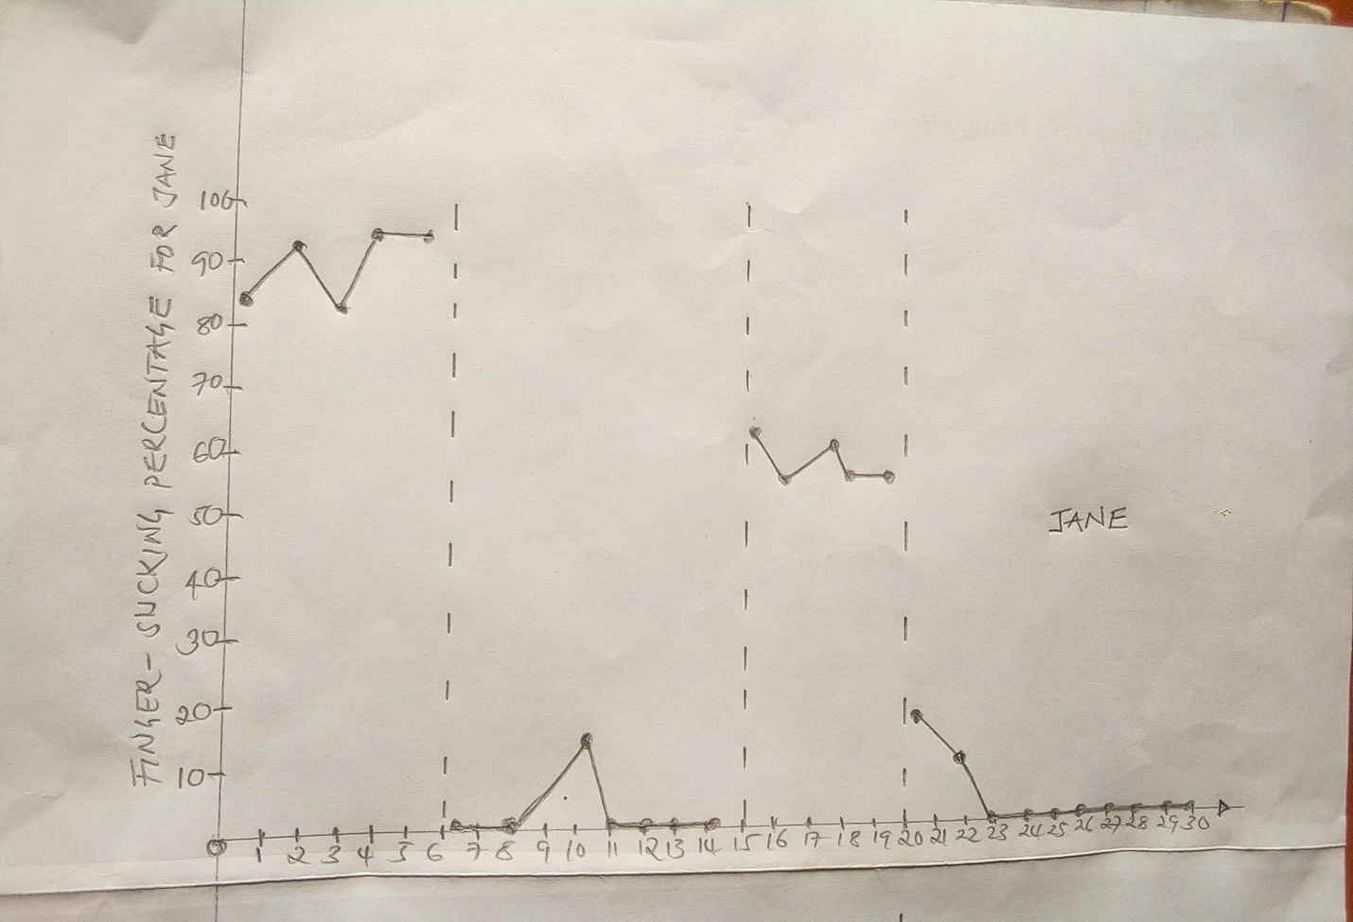
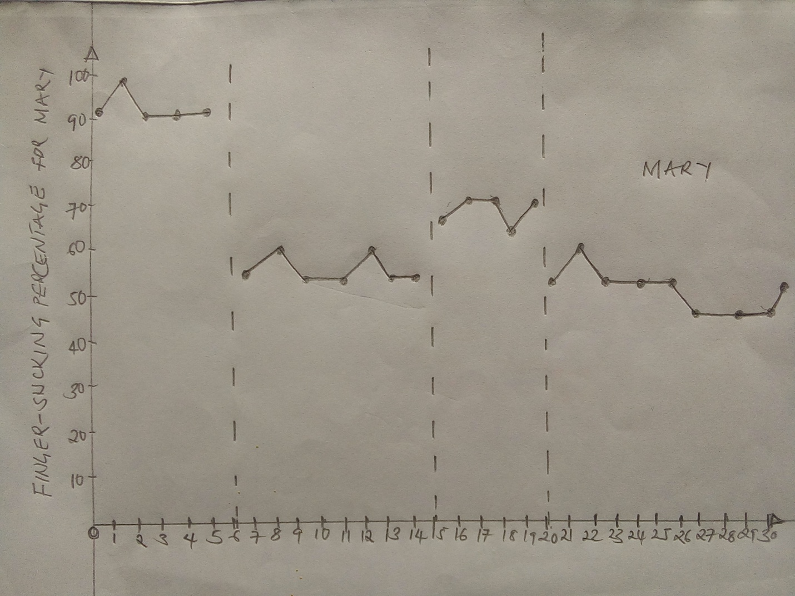
Discussion
The phase 1 results suggested that the finger sucking habit of the girls did not show that their behavior was maintained by social reinforcement (Tanaka et al., 2016). Although the control condition which involved the use of the ball to engage the children through social support proved helpful, the reduction level with Mary happened with a lot of problems. It was not as easy as the case with Jane. For this reason, the use of a ball as a destructor did not prove the best intervention for Mary’s behavior. On the side of Jane, the introduction of the ball- holding resulted in the elimination of finger sucking and therefore, attributed to sensory extinction. In short, ball- holding prevented Jane from sucking her fingers, and therefore, the oral stimulation caused by finger sucking was eliminated, leading to the end of the behavior. With the ABABA pattern of curbing finger sucking, Jane responded positively while Mary remained adamant about changing. It is, therefore, evident that Mary’s thumb sucking habit can only be eliminated through punishment, the results which she portrayed positively in phase 1.
The observation made by the mothers of the two participants suggested that the effect of the researcher- conducted sessions could manifest more when family members at home. However, the two participants showed a tiny finger- sucking occurrences when they were alone (Altundağ 2018). Also, the parents reported that social reinforcements helped considerably in reducing finger sucking. According to Jane’s mother, positive social attention worked perfectly while Mary’s mother said that she observed positive results when she disapproved her daughters sucking behavior. Therefore, the behavior could only be curbed through negative reinforcement (punishment).
Strengths
The research provides a principal concentrate to assess the utilization of the ABA design for finger sucking in a five years old child and the primary investigation to gather social legitimacy information on its utilization (Altundağ 2018). The outcomes recorded for Jane point out that ABA is possibly a helpful and adequate intercession for diminishing an assortment of hand-to-head habit. The high adequacy evaluations acquired from Jane and her mom, are intriguing, given that intercessions, including the utilization of discipline (particularly that of positive punishment), have been portrayed as less adequate than their social interaction. Research-based on ABA therapy should keep on acquiring harmonious appraisals from the participants (children) and their parents or guardians (Altundağ 2018). Finally, this investigation is the first to assess the effect of a tangible attenuator (ball) in a healthy developing child. The research also is the first to assess the utilization of ABA therapy with normal working time. Since the results with the second phase show the intervention reduced the occurrence of thumb sucking without positive social reinforcement, extra research with these techniques is justifiable.
Limitations
A few constraints of this research need to be identified. In the first place, ends with respect to the particular tangible results that kept up every Child’s finger sucking could not be identified. A subsequent limitation is that decisions about the viability of the ABA for curbing finger sucking must be tempered because of the way that its presentation conditions and are liable to treatment requesting impacts (Altundağ 2018). The observers made some errors during the estimation of time when occurrences of and nonoccurrences for the thumb- sucking occurred. Also, the calculation and analysis of the data were tedious. Lastly, the research is time-consuming since it requires participants to be closely monitored. Therefore, the mothers kept an eye to the pattern of behavior for each individual child.
The research creates room for future improvement in related research. First, future research should aim at expanding the practical investigation techniques for consequently fortified conduct. Second, we disposed of Mary’s finger sucking throughout a while and blurred utilization of the ball. Future research should concentrate on deciding the base measure of time important to smother this kind of conduct with the goal that the constriction method can be avoided in an auspicious way (Altundağ 2018). Additionally, on the grounds that it is hard to separate between the conduct changes delivered by reinforcement dispute and strengthen substitutability, scientists should proceed without use techniques to reduce the incitement created by conduct kept up without socially intervened outcomes.
In conclusion
The research proved that the habit of sucking fingers results from a number of stimuli. One of the major causes of the habit is such for pleasure when social support lacks. Therefore, children will opt for finger sucking in order to feel secure when alone or living in a socially unsupportive environment. Besides, different strategies and intervention procedures apply in the curbing of finger sucking habit. It means that two different children may respond differently to the same reinforcement. Thus, researchers, medical practitioners, and parents need to identify the suitable reinforce of their children’s thumb-sucking behavior because of the use of wrong therapy results to the hindrance of the children’s developmental process. I, therefore, urge future therapies to be thoroughly researched.

References
Altundağ, Y. (2018). Çocuklarda Parmak Emme Davranışı. Ege Bilimsel Araştırmalar Dergisi, 1(1), 28-36.
Asadollahpour, F., Yadegari, F., Soleimani, F., & Khalesi, N. (2015). The effects of non-nutritive sucking and pre-feeding oral stimulation on time to achieve independent oral feeding for preterm infants. Iranian journal of pediatrics, 25(3).
Bishara, S. E., & Larsson, E. (2007). FINGER HABITS: Their Effects and Their Treatments: Part 1. Dental Assistant, 76(1), 14.
Ellingson, S. A., Miltenberger, R. G., Stricker, J. M., Garlinghouse, M. A., Roberts, J., Galensky, T. L., & Rapp, J. T. (2000). Analysis and treatment of finger sucking. Journal of Applied Behavior Analysis, 33(1), 41-52.
Tanaka, O., Oliveira, W., Galarza, M., Aoki, V., & Bertaiolli, B. (2016). Breaking the thumb sucking habit: When compliance is essential. Case reports in dentistry, 2016.
Woods, D. W., Miltenberger, R. G., & Carr, J. E. (2006). Introduction to the special section on clinical behavior analysis. Journal of applied Behavior analysis, 39(4), 407.
Yadav, A. (2017). Behavioral Treatment Strategy for Early Onset of Tricho llomania with Simultaneous Thumb Sucking.

